1. FACE VALUE: THE POWER OF IMAGES AT APHRODISIAS

How Digital Resources Can Tranform our use of Palaeography in understanding Inscriptions.

*Dr. Abigail Graham*

*The University of Warwick (Lecturer)*

*Abigail.graham@warwick.ac.uk*

Possibly for subject panel: Dating criteria for epigraphic material: possible approaches.

**Abstract:**

This paper will consider how the publication of a large digital corpus (*The Inscriptions of Aphrodisias* [Reynolds, Roueche & Bodard, 2007] has shaped the assessment of inscriptions, particularly regarding palaeography and the dating of inscriptions. A case study of dedicatory inscriptions from the Temple of Aphrodite at Aphrodisias will explore how our approach to palaeography and dating has evolved with digital resources, identifying areas where challenges remain and considering how improvements could be made in both our approach to and in publication of epigraphic materials.

**Keywords**

Dating, Palaeography, Ordinatio, Letter forms, Aphrodisias, Context, Recarving.

**1.1 Introduction**

* + 1. **Caveat Lector: Defining Palaeography and traditional approaches**

As the co-ordinator and lecturer on three graduate level courses of Roman Epigraphy, I am invariably asked the same question: how do you use letterforms to date inscriptions? My answer is always the same: “very carefully”. Studying palaeography within the discipline of ancient epigraphy can be a journey into thorny hedge where one can easily “fall into that category of human endeavor known as stylistic attribution and inevitably involve subjectivity”.[1] Stephen Tracy advises that palaeographic surveys should be carried out with caution: “Caveat Lector must needs be our motto”. The study of palaeography is problematic on a number of levels, both in the way it is defined and the ways in which it is employed. Many scholars dismiss lettering as a means of dating and they make an important point: dating by a single criterion, especially a stylistic one, is somewhat precarious. When studied in isolation, letterforms present stylistic variations that may be characteristic of a specific individual, workshop or an urban area. While observations about carving techniques can be helpful in specific case studies, they are more problematic when applied generally on a broader scale (e.g. to larger geographical areas or time trame) where archaisms, local styles, and variations can create distortions.[2] Similar caution would be applied in dating a sculpture on the basis of a hair fragment. Analysis of statues considers a number of factors, material, hairstyle, drapery and/or context. Inscriptions are doubly difficult, as they fall into categories of both text and an object. While there is potentially more information, there is also a greater chance that it will be contradictory. Thus the use of lettering, an “imprecise science”, is better used in combination with a number of different factors.[3] Despite the aforementioned limitations, a number of informative palaeographic studies have been produced. The success of these is based on detailed commentaries on a specific corpus of material, a transparent methodology and the incorporation of numerous high quality images.[4]

A second issue in the study of palaeography involves the access and publication of epigraphic materials. Access to large corpora of inscriptions has traditionally been limited to a small audience of scholars and site visitors. Apart from a few museum collections, which happen to have inscriptions arranged in roughly chronological order,[5] there are few places where one can visually experience the development of carving styles over time. For the lucky few who attain access (and permission) to study a large corpus of inscriptions, publishing these texts with supporting images can be challenging and expensive. Studies of palaeography in ancient inscriptions have often been, by necessity, selective with images making it difficult for both the author and readers to develop a detailed understanding of carving trends and practices. In this traditional format, inscriptions were also separated from their archaeological context and the accompanying artwork while the reader, viewing only the lettering, was often removed from the visual elements of the inscription (e.g. the type of stone, use of spacing and decoration, letter size). This is a suboptimal way of assessing epigraphic evidence.

The advent of online corpora have increased both the access and the development of discussions regarding epigraphic monumentality, including new methodologies, approaches as well as attempts to redefine genre classifications and terminology.[6] A number of recent studies have used changes in the appearance of inscriptions over time, such as the use of different media, decorative and paratextual elements[7] (e.g. ivy leaves as interpuncts (*hederae distinguentes),*[8] abbreviations[9] and spacing between words[10] alongside lettering, as dating criteria.[11] Panciera’s recent article, in particular, advocates the significance of the public context and visibility of inscriptions.[12] In this vein, it is worth considering how the physical characteristics of an inscription belong within a broader assessment of a culture of writing. Is palaeography the study of letterforms alone? Was a focus on letterforms a deliberate choice or a product of the traditional constraints in accessibility and publication of epigraphic materials? The following case study from Aphrodisias will explore these questions further.

**1.1.3 Outline**

The focus of this paper is a series of rather unimpressive column dedications from the temple of Aphrodite at Aphrodisias. While the information recorded in the texts is unremarkable, the journey of these inscriptions from their publication as part of an epigraphic corpus to a recent digital publication reveals an epic transformation in the format and approach to these materials. This study will begin with brief overview of previous published editions (e.g. *MAMA* volume VIII, 1962) followed by an assessment of the information available on the current Inscriptions of Aphrodisias (2007) website. Through careful assessment of text (including formula, vocabulary and spelling) and its presentation (the arrangement of the text, use of decoration and spaces, as well as lettering) in the images provided, this survey will demonstrate how the availability of published images and inclusion of dating criteria have increased the amount of information available whilst also adding clarity to the process of dating an inscription. By examining how we define and use palaeography to evaluate inscriptions on the *Inscriptions of Aphrodisias* website (*IAph 2007*), we can observe how the discipline has evolved and what changes may be possible in approaches and the publication of epigraphic material.

Key Questions:

*What elements of the text are available to us in different media?*

*How do we record the dating process and criteria?*

*How do we represent (and attempt to reconcile) contradictory information?*

* 1. **Publishing inscriptions: A Case Study of Column Dedications from The Temple Of Aphrodite at Aphrodisias**

**1.2.1 A brief introduction to the inscriptions IAph 1.4-1.6.**

Three inscriptions, each of which record the dedication of a column at the Temple of Aphrodite, will be the subject of this survey. The first two texts were noted as early as the 18th century and copied in a notebook by the British Architect Deering in the early 19th century. A third version of the text, was uncovered during excavations at the temple site by the French Engineer Gaudin in the early 20th century.[13] The inscriptions are recorded on *tabella ansata* (0.745 x 0.465m) as part of fluted marble columns of the *peristasis*, some of these have been reconstructed in modern restorations on the site.

These texts can be dated through a number of different criteria. Contextual association with construction of the temple, dates between the end of the 1st century BC and the early 1st century AD, though the land was clearly in use well before this time. [14] This is corroborated by coins depicting the temple, which date from 2 BC- 14 AD.[15] Prosopography is also informative: Gaius Julius Zoilos (freed by Caesar or Octavian), who dedicated the theatre at Aphrodisias *ca.* 28 BC, also dedicated the *naos* of the temple (IAph 1.2), perhaps posthumously. [16] The benefactor of the columns in this case study, Eumachos Diogenes, also comes from an established family that flourished well into the 2nd century AD.[17] Finally, the formula of the text the inscription and the vocabulary, particularly the term *philokaisar,* suggest a late Republican or Augustan date.[18] Before encountering the inscriptions face to face, the dating, function and meaning of these inscriptions appears to be quite straightforward. So let us examine the experience of viewing these inscriptions various published formats.

**1.2.2. Publishing IAPH 1.4 and 1.5 in MAMA VIII (nos. 347 & 348): A series of copies?**

Cormack published the first comprehensive catalogue of inscriptions from Aphrodisias as part of his *Monumenta Asiae Minoris Antiqua* volume VIII in 1962. This was a great undertaking that included texts as well as images. Two of the three texts (IAph 1.4 & 1.5) were published here as MAMA 437 and MAMA 438 respectively, while the third text was merely mentioned as a further copy.

MAMA 437

Εὔμαχος Ἀθηναγό-

ρου τοῦ Ἀθηναγόρου

τοῦ Εὐμάχου Διογένη-

ς φιλόκαισαρ καὶ Ἀμιὰς

Διονυσίου φύσι δὲ Ἀδρά<σ>του

τοῦ Μόλωνος Ὀλυνπιὰς

τὸν κίονα θεᾷ Ἀφροδίτῃ

καὶ τῷ δήμῳ.

MAMA 438

Εὔμαχος Ἀθηνα-

γόρου τοῦ Ἀθηναγό-

ρου τοῦ Εὐμάχου Δι-

ογένης φιλόκαισαρ

καὶ Ἀμμιὰς Διονυσί-

ου φύσι δὲ Ἀδράστου

τοῦ Μόλωνος Ὀλυν-

πιὰς τὸν κίονα θεᾷ

Ἀφροδίτῃ καὶ τῷ

δήμῳ.

*Translation by author*

Eumachos Diogenes, son of Athenagoras, the son of Athenagoras, the son of Eumachos, devoted to Caesar, and Ammias Olympias, daughter of Dionysius, the natural daughter of Adrastus, the son of Molon, (dedicated) a column to the goddess Aphrodite and the People.

The two published texts reveal similar inscriptions with a few variations.[19] IAph 1.4 (MAMA 437) has a slightly less impressive *ordinatio*, particularly in line 4 with an odd line break, a misspelling of Ammias (as Amias) and Adrastus (line 5) with a sigma omitted. It is difficult to determine how or why these errors occurred without indications of spacing or an examination of the stone. One could argue that spelling and arrangement of the text were not important to a broader audience at Aphrodisias, however, this is negated by a second copy of the dedication (IAph 1.5, MAMA 438), which portrays a more skillful execution and arrangement of the text. Spelling errors are rectified and the arrangement of the text creates a distinction in Line 5 between Eumachus and Ammias, and for the *demos*, which is isolated on the last line. These subtle variations only emerge with a close reading of the text, and it would be easy to overlook them. The published format of the texts also makes them appear similar in lettering and arrangement (e.g. left indentation).

The small (thumbnail) and low quality image provided in MAMA 437 provides a basic understanding of the appearance of the inscription, though it does not allow for a critical assessment of the lettering or arrangement of the text. The image reflects lettering that is recognizable (to the trained eye) as late Republican/ early Augustan at Aphrodisias with deep incisions, small serifs, as well as varying letter heights, but it is not sufficient for a detailed study. MAMA 438 is not published with a photograph, so one must rely upon a comparison of the texts alone.

The third text version of this text is mentioned in the commentary and based on the information provided (two similar texts and a reference to a “copy”) one would expect that it was very similar. The same editorial practice is employed in the parallel column dedications from a different benefactor (I.Aph 7 & I.Aph 8), where 2nd version of the text is noted (IAph 1.8) but only one (I.Aph 1.7, MAMA 450) was published. The apparent verisimilitude of the column dedications is corroborated by the published images, which depict two inscriptions (MAMA 437 and MAMA 450) with similar late 1st c. BC/early 1st c. AD lettering. When publishing a large corpus of inscriptions, referring to copies is understandable. However, treating texts as “copies” as opposed to individual monuments can, and in this case will, prove problematic.[20] While MAMA VIII offered a broader audience access to the inscriptions at Aphrodisias, the approach to the inscriptions and the quality of the images also imposed limitations that made it difficult to analyse the physical elements of the inscription or to question the proposed texts and restorations.

**1.2.3 Living in a Digital World: The Publication of Column Dedications in *IAph 2007* (IAph 1.4.)**

The Inscriptions of Aphrodisias project was a groundbreaking endeavour both for publishing epigraphic materials and employing Epi Doc conventions with XML for marking up ancient documents. Its success has inspired a number of significantly larger projects with international scope and collaboration. The approach to the materials is detailed with categories covering physical characteristics, history of discovery and bibliography (which is important given the wealth of superlative scholarship).[21] In addition to search functions, the page is more interactive, the texts have been revisited, translations added, as well as commentary with weblinks to parallel texts. The organization of the inscriptions by context allows the reader to view the inscriptions in context and to gain a better understanding of the area’s “epigraphic habit” (Figure 1: Screenshot of IAph 4 webpage).

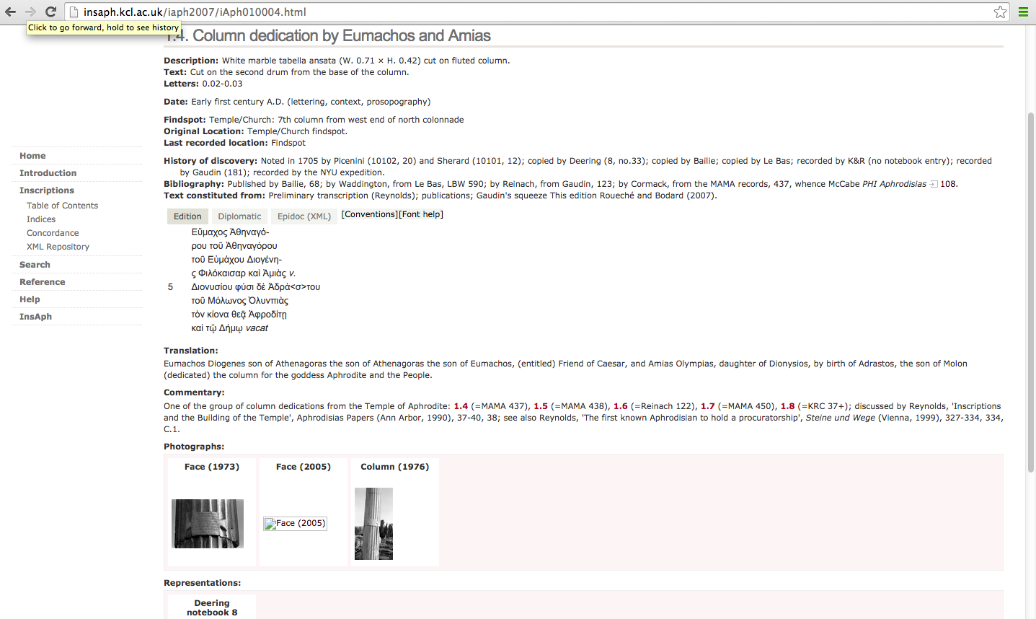

In addition to the format of the webpage, a number of images have been published along with a drawing from Deering’s notebook from the early 19th century. These resources provide an opportunity not only to view the inscription but to see how it has been studied over time. The dating of the inscription includes a list of the criteria upon which it was based: lettering, context, prosopography, adding a degree of transparency to the dating process. While the lettering is not subject to further description, the inclusion of weblinks to parallel texts allows the viewer to compare and contrast different inscriptions, developing his/her understanding this element.

The published texts of IAph 1.4 and MAMA 437 present one significant variation: the inclusion of space indicators within the text. This practice allows the reader to see how the use of space relates with the text of the inscription, particularly in the case of line 4, where challenges in the text (misspelling of Ammias and carrying over of a single letter from the previous line), can be observed in the inclusion of a *vacat* at the end of the line.[22] The indentation on the last line also reveals a left orientation of the line which is more common in Late Republican/Augustan texts at Aphrodisias (e.g. IAph 1.1, 1.7, 1.8 and 1.38), as opposed to the “justified” approach (indentations on both sides of the text to accentuate a name or word), which is more common in later Imperial inscriptions at Aphrodisias.

MAMA 437

Εὔμαχος Ἀθηναγό-

ρου τοῦ Ἀθηναγόρου

τοῦ Εὐμάχου Διογένη-

ς φιλόκαισαρ καὶ Ἀμιὰς

Διονυσίου φύσι δὲ Ἀδρά<σ>του

τοῦ Μόλωνος Ὀλυνπιὰς

τὸν κίονα θεᾷ Ἀφροδίτῃ

καὶ τῷ δήμῳ.

IAph 1.4.

Εὔμαχος Ἀθηναγό-

ρου τοῦ Ἀθηναγόρου

τοῦ Εὐμάχου Διογένη-

ς Φιλόκαισαρ καὶ Ἀμιὰς *v.*

5 Διονυσίου φύσι δὲ Ἀδρά<σ>του

τοῦ Μόλωνος Ὀλυνπιὰς

τὸν κίονα θεᾷ Ἀφροδίτῃ

καὶ τῷ Δήμῳ *vacat*

High quality images on the website facilitate connections between the published text and the inscription. In the image of IAph 1.4 (Figure 2. Photograph of IAph 1.4), one can to observe how descriptive elements manifest themselves in an inscription: how varying letter sizes (2-3 cm) represent a lack of uniformity and crowding as space becomes more cramped, and how, after the beautifully spaced upper lines (lines 1-3) the carver struggled (line 4) to fit the letters in, possibly noticing his spelling error only when there was extra space at the end of the line.

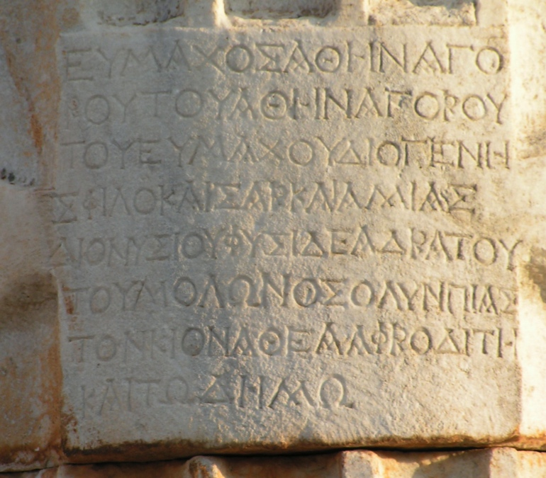

Alongside spelling and the arrangement of the inscription, Letterforms are more readily observed. Overall, the lettering is less uniform than later Imperial dedications, serifs are small and the strokes are both thick and deeply incised. Letter height varies significantly as does the size of omicrons (though this can be seen in a poorly rendered text throughout the Roman period). Angular forms such as alpha, lambda, and mu all intersect at the top meeting at sharper angles than the more square versions of these letters that predominate in Imperial (post Augustan) inscriptions.[23] Letters also bear stylistic elements of the time: epsilons have a connected middle bar (this is often disconnected in Imperial versions of this letter), the rhos have small legs, making them appear more like their Latin counterpart, and the omicron has an oval shape with serifs only at one end of the lower bars.[24] Comparing these letterforms with parallel dedications at the temple (IAph 1.1, 1.2 (Zoilos’ dedications), 1.7 and 1.8) reveals many similarities. Letterforms alone are not diagnostic but when combined with other elements, they can add to our understanding of a date.

**1.2.4. Looks can be deceiving. When Inscriptions defy our expectations: IAph 1.5 and IAph 1.6.**

Based on the publication of these inscriptions in MAMA VIII, one could easily come to the conclusion that all the column dedications at the Temple of Aphrodite looked quite similar. However, upon visiting the site of Aphrodisias in the summer of 2004, I was (yet again) to be denied a simplistic interpretation of an inscription. Courtesy of the *IAph2007* website, a broader audience can now bear witness to complex nature of these inscriptions. The first disparities between the two inscriptions (IAph 1.4 and IAph 1.5) can be observed in a comparison of letter sizes. IAph 1.4 records letters between 2-3 cm (with a variation of 1 cm), while IAph 1.5 varies only between 2.5- 2.75 cm (a variation of .25cm). The reductions in variation of letter size are part of a general standardization in letterforms during the Julio-Claudian period at Aphrodisias.[25] While significant variations in letter size can be observed in poorly executed inscriptions throughout Aphrodisias’ history, one may not expect such a significant variation between two “copies”.[26] The published text of IAph 1.5 also indicates indentations on both sides of the word *demos* in the bottom line. While double indentations are not unknown in Augustan inscriptions at Aphrodisias, they are more common in later Imperial inscriptions.[27] These discrepancies, which suggest that the two inscriptions may have been less similar in appearance, illustrate the importance of reading the descriptive elements of an inscription carefully.

IAph 1.5.

Εὔμαχος Ἀθηνα-

γόρου τοῦ Ἀθηναγό-

ρου τοῦ Εὐμάχου Δι-

ογένης Φιλόκαισαρ

καὶ Ἀμμιὰς Διονυσί-

ου φύσι δὲ Ἀδράστου

τοῦ Μόλωνος Ὀλυν-

πιὰς τὸν κίονα θεᾷ

Ἀφροδίτῃ καὶ τῷ

*vac.*Δήμῳ *vac.*

MAMA 438

Εὔμαχος Ἀθηνα-

γόρου τοῦ Ἀθηναγό-

ρου τοῦ Εὐμάχου Δι-

ογένης φιλόκαισαρ

καὶ Ἀμμιὰς Διονυσί-

ου φύσι δὲ Ἀδράστου

τοῦ Μόλωνος Ὀλυν-

πιὰς τὸν κίονα θεᾷ

Ἀφροδίτῃ καὶ τῷ

δήμῳ.

An image (Figure 3 Photograph of IAph 1.5) illustrates further differences between the appearance of this inscription and the comparative materials from the site (IAph 1.1, 1.2, 1.4, 1.7 and 1.8).

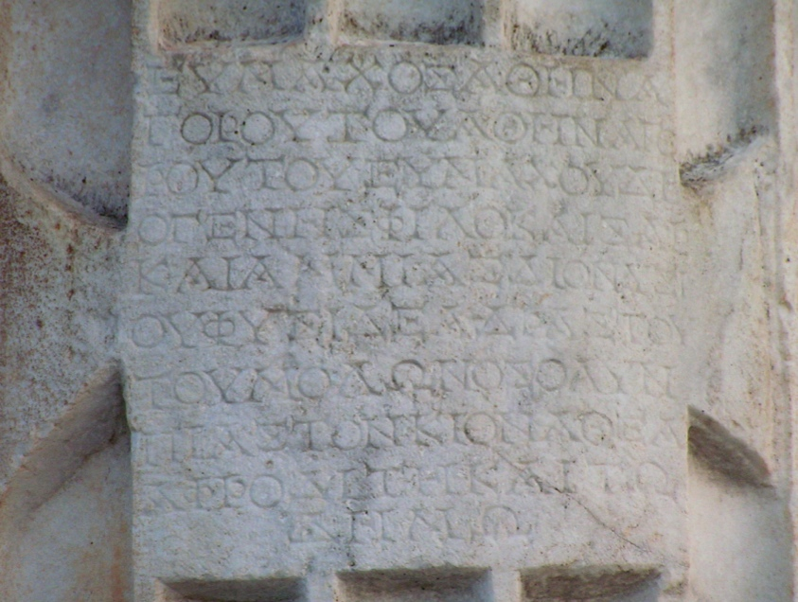

The high quality image reveals square and regular letterforms (e.g. omicrons are less oval and more precisely rendered throughout) with a clear contrast between slender strokes and large deep triangulate serifs. There are no legged rhos, the middle bars of the epsilons are separated from the stem, and the omegas are circular with two large bars that are heavily serifed on both ends (e.g. compare the omega on the bottom line of IAph 1.4 with its counterpart of IAph.1.5). These traits along with others (e.g. letter size and use of spacing noted above) are commonly attributed to late 1st /2nd c. AD inscriptions at Aphrodisias, and are absent from comparative Augustan materials on the site (e.g. IAph 1.1, 1.2, 1.4, 1.7 and 1.8, including a Julio-Claudian dedication 1.102). Although one must be careful with stylistic factors, especially when archaisms can be used, it is worth noting when a number of features that are attributed to a later period, seem to suddenly emerge nearly a century early.[28] Any one of these features, letter variations, stylistic letterforms, use of serifs, indentations in the text, correction of errors in a previous text, would not stand well alone, but taken together, a more compelling case can be made for the reassessment of this inscription’s date.

The website records the date of this inscription just like IAph 1.4: citing “context, lettering and prosopography.” For those trying to gain an understanding of letterforms at Aphrodisias, this is somewhat confusing and it is not the only example in which the lettering and organization of the inscription do not match date provided.[29] The date of the text is not incorrect, insofar as it was originally inscribed at this time and the prosopography as well as the formula of the text support this. However, one struggles to see how the lettering and/or the arrangement of the text corroborate this date. An answer may be found in further examination of the inscription’s context and prosopography. In addition to a number of earthquakes, new temenos of the temple was added under the emperor Hadrian, a time during which Athenagoras’ descendants were alive and prospering in Aphrodisias.[30]

One benefit of the website is that it facilitates searches for parallel texts in this context and this period. A Hadrianic building dedication from the temple, IAph 1.174 (Figure 4: Photograph of IAph 1.174) reveals similarly rendered letterforms with little variation in size and a number of stylistic similarities: thin strokes with deep triangulate serifs, the omicron with double serif bars, an epsilon with a separated crossbar. Similar observations can be made on a number of Trajanic and Hadrianic texts at Aphrodisias (IAph 4.308, 5.9, 5.208 (Hadrianic Baths)). A theory of later recarving would reconcile a number of disparities in this inscription.

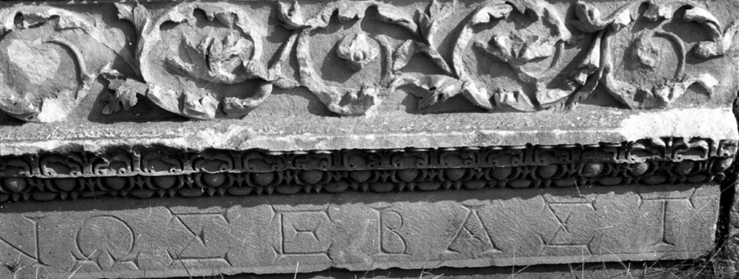

This is not to say that IAph 1.5 was definitely a Hadrianic recarving, but to observe that, contrary to what is recorded in the *IAph2007* dating criteria of this inscription, the lettering and arrangement of text on the stone do not reflect an inscription that is an obvious contemporary with the other column dedications at the temple. The context and prosopography of the inscription do not rule out a later date and the text, which rectifies issues in both organization and orthography of IAPh 1.4, reflects an inscription that may have responded to an earlier monument.

The entry for IAph.1.6 represents a different response to a similar problem. It demonstrates that scholars are willing to use letterforms to support a recarving when the case is sufficiently extreme. The text, only mentioned in MAMA VIII as a “copy”, presents a number of irregularities, repeating some errors, correcting others, and making quite a few new ones. Whilst maintaining the first 3 lines of the arrangement in IAph 1.4, this inscription compounds the error on line 4 by reduplicating two letters in the name Diogenes. Line 5 repeats the misspelling of Ammias, corrects the misspelling of Adrastos (line 6), but creates two new errors in line 7, missing out the nu on Molon and Olynpias, then repeating the column phrase in lines 9- 10.

IAPh 1.6.

Εὔμαχος Ἀθηναγό-

ρου τοῦ Ἀθηναγόρου

τοῦ Εὐμάχου Διογε-

{γέ}νης Φιλόκαισαρ καὶ

Ἀμιὰς Διονυσίου φύσι

δὲ Ἀδράστου τοῦ Μό-

λω<ν>ος Ὀλυ<ν>πιὰς τὸν κί-

ονα θεᾷ Ἀφροδίτῃ {τὸν}

{κίονα} καὶ τῷ Δήμῳ

Reading this inscription is even more of challenge (Figure 5. Photograph of I.Aph 1.6), one can suffer vertigo as the lines run up and down and the letters run into the margins. There is no use of spaces or decorations to clarify or distinguish sections of the text and there are quite a few inadvertent errors to make it difficult, even to the trained eye. Although the prosopography and context support an earlier date, the entry suggests that this “inelegant” text was “recarved ?” The entry does not, however, propose a date or explain why, in this instance, recarving is a viable conclusion. While a methodology is evident in the *IAph2007* dating format, it is not employed consistently or transparently in this case.

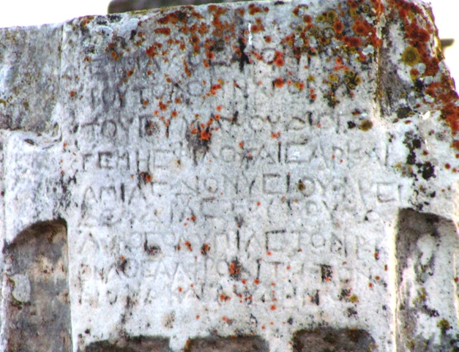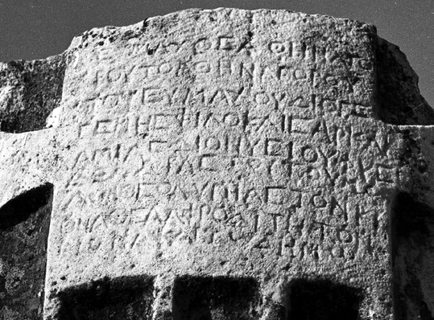

The inclusion of numerous images proves crucial here, where moss now covers parts of the text that were legible in the 1970’s. The lunate omega on the bottom line (barely visibly in the recent photo) along with the lunate sigmas indicate that the inscription is from the late Antique period at Aphrodisias, possibly after an earthquake in 359 BC (for parallels see *ALA* 29 and 30), before the conversion of the temple into a Christian church (after 450 AD).[31] Acknowledging that the text was reinscribed centuries later affords further insight into both the inscription and act of recarving as a process that often changed an inscription but did not necessarily improve it.

The three inscriptions betray fundamental differences, which reveal a rich and complicated tale of a column’s life at Aphrodisias. While minor differences in the text do not change our translation of the words, a close analysis of the resulting inscription informs our understanding of the arrangement of the text, the potential dating of the inscription, as well as the relationship between text and monument. Recarving was not a highly unusual phenomenon in the ancient world but by minimizing the conflicting elements of these inscriptions, one potentially overlooks this aspect of an inscription.[32]

**1.2.5 Conclusions on the case study**

This survey of column dedications has demonstrate how a series of inscriptions, which were represented as a series of similar texts in MAMA VIII can be seen in a fundamentally different way in *IAPh 2007*. The digital publication has a number of advantages: it applies a more rigorous approach to the text in XML thus illustrating the arrangement of the inscription more clearly, the date is given some transparency through a list of applied criteria, the descriptors, such as the lettering size of the inscriptions, provide more information. The images of the inscription in drawing and its context provide an invaluable resource that allow the reader to better understand the relationship between text, inscription and context, including references and better accessibility to parallel inscriptions. In terms experiencing an inscription in a digital world, this is probably as close a person can come to assessing the face value of an inscription. It is a tremendous step forward in addressing the longstanding limitations inherent in the publication of epigraphic evidence, though some challenges remain. The final section will consider how we might further use this information, in terms of adding clarity and transparency to the dating process, as well as in our approach to these materials.

**1.3. Palaeography in a Digital World: Monumental Problems & Solutions**

* + 1. **Digital Epigraphy. New Method: New Methodology?**

For students and academics alike, dating by letter forms is an almost “mystic” practice: something upon which experts often comment but more rarely explain or demonstrate in practice. Recent epigraphic handbooks keep the term palaeography at arms length, using it interchangeably with discussions of letterforms.[33] The caution of these scholars is justified and understandable: conclusions based on a single element of an inscription are precarious and, perhaps more importantly, they represent a mode of scholarship that views inscriptions in a fundamentally different way than they were viewed in antiquity. Writing, both ancient and modern, is a product of a number of factors, all of which functioned together in the image of writing (margins, lettering, indentations punctuation).[34] As few would look at a document today and say “that’s a fine Helvetica 10 point!,” we should be cautious in an assessment of palaeography that excludes the visual elements which were inextricably linked an inscription’s appearance (e.g. alignment, margins, spacing, punctuation). Modern definitions and studies of manuscripts suggest a broader scope of inquiry, which includes handwriting together with decorations and spatial organization as well as subsequent comments in the margins.[35] These practices suggest a discipline with an interest not only in the evolution of lettering but in the appearance and development of a culture of writing.

While traditional text-based modes of publication such as MAMA VIII have, at times, constrained the study of hands to an analysis of lettering, digital corpora offer new opportunities to view, analyse and incorporate broader scope of visual elements in the interpretation of an inscription. This is not to say that the traditional methods or charts of letterforms development should be abandoned, merely that the methodology could be expanded, as it has been in this case study, to include aspects of textual organization (spacing, use of decoration and punctuation, letter size). The question arises: how do we achieve this through the website materials?

**1.3.2 Employing change: How we might improve presentation of materials on the website.**

One difficulty of the current site, observed in the assessment of IAph 1.5 is that despite the clear criteria for dating, the terms do not reflect a consistent methodology in dating, or the contradictions in the process. This is dangerous for those who simply accept the dates provided, and confusing for those who try to apply or develop a sense of letterform development. When a recarving is suggested IAph 1.6, there is little to explain how we know it was recarved (letterforms) or when the recarving took place (use of parallel texts), though both resources are available on the website. The wealth of visual, textual and contextual information in *IAph 2007*, offers an opportunity, not only clarify, but to add greater transparency to the process of dating and how lettering is used in an inscription. This could be achieved by adding a few pages to explain and illustrate elements dating criteria (each with a significant Caveat Lector on the use of these elements). Firstly, one could add a page outlining the dating criteria, providing a brief description of each (e.g. context, lettering and prosopography) together with a sample case study (or two) of how these factors are applied in an inscription.

Further improvements, could be made with additional pages on lettering and context. While lettering is undoubtedly employed in dating inscriptions at Aphrodisias, one must also consider how this dating is represented in the published materials. Epigraphers, who have described monumental lettering as ‘Augustan’, ‘distinctively Julio-Claudian’ or ‘Domitianic’ have already acknowledged that such distinctions exist at Aphrodisias, but the classifications remain undefined.[36] While such definitions are often problematic, so is a situation in which a broader audience accepts and uses a series of dates, without understanding how certain criteria have been used in formulating a date. Undertaking a detailed palaeography for a site is a massive endeavor, and one that can prove contentious on a number of levels. However, a page about lettering (together with aforementioned element of textual organization) could be added with brief descriptions of trends (periods of ca. 60-70 years) and references to a few inscriptions as illustrations. This could be supported by a single case study, such as this one, to show how these elements are used as well as how they can be problematic.

Finally, while inscriptions are given a good deal of context in *IAph 2007*, the epigraphic information remains separated from the archaeological studies. Both of these are factors in the dating process and, as we observed in IAph 1.5 and 1.6 can often facilitate the study of an inscription, both in reconciling discrepancies and searching for parallel inscriptions. With inscriptions grouped by context and an excavation history that is referenced (but not explained) it might be helpful to have a brief building history for each context. In the case of Aphrodisias, these materials and further bibliographies are available on NYU excavation websites and could be easily connected with weblinks.[37]

The benefits and the challenges observed in the *IAph 2007* digital publication are applicable to a number of digital resources. As we attempt to bring corpora of unprecedented size to a digital realm, we must consider not only how we represent this information but how we engage a wider readership in epigraphic materials. It would not take a great deal of work to augment the scope of *IAph 2007* from an academic resource into one also achieves a didactic aim of illustrating how we use epigraphic evidence to date inscriptions. We have the potential now, to present inscriptions at face value, not only as texts but as contradictory objects whose stories, whether conveyed on stone or a computer app, are subject to the same conventions, complexities and imperfections as the humans who created them.

Bibliography

ALFÖLDY, G. “Eine Bauinschrift aus dem Colosseum” *ZPE* 109 (1995) 195-226.

BODEL, J. *Epigraphic Evidence,* New York, 2001.

BUONOCORE, M., “Epigraphic Research from it’s Inception: the Contribution of Manuscriptions” in Bruun and Edmunson, 2015, 21-37.

BURASELIS, K., *Kos. Between Hellenism and Rome, Studies on the Political, Institutional and Social History of Kos from ca. the Middle of the Second Century BC Until Late Antiquity. Transactions of the American Philosophical Society vol. 90, part 4*, Philadelphia, 2000.

BRUUN, C and EDMONSON, J. *Oxford Handbook of Roman Epigraphy,* Oxford, 2015.

CALABI LIMENTANI, I., *Epigrafia latina* 4th edition, Milan, 1991.

COOLEY, A. *The Cambridge Manual of Latin Epigraphy,* Cambridge, 2012.

- “Paratextual perspectives upon the SC de Pisone patre” Jansen, L (ed) *The Roman Paratext*, Cambridge, 2014.

CHANIOTIS, A., *New Inscriptions from Aphrodisias (1995-2001)* in AJA 108 (2004) 377-416.

DI STEFANO MANZELLA, I. *Mestiere di epigrafista. Guida all schedatura del materiale epigrafico lapideo.* Rome,1987

- “Problemi di paleografía in epigráfica latina.” in Solin, Salomie and Liertz, 1995, 163-181.

- “Le integrazione tra testo e manufatto/monument in epigrafia” in *Acta XII Congressus Epigraphiae Graecae et Latinae.* ed. M. Mayer et al. (2007) 393-418.

CALDER W. & CORMACK J.M.R., *Monumenta Asiae Minoris Antiqua* vol. VIII, Manchester, 1962.

ECK, W., “There Are No *Cursus Honorum* Inscriptions” in *Monument und Inschrift.* Berlin, 2010. .

GRAHAM, A., “The Word is not Enough. A new methodology for assessing monumental inscriptions: A Case Study in Ephesus” *AJA* 117, 1-30.

-(*forthcoming)* “Reappraising the Value of Same Text Relationships*”* in A. Petrovic (ed. ) *Text and Materiality,* New York, 2015.

HARRIS, W., *Ancient Literacy*, Cambridge, 1989.

HOMMEL. H., “Das Datum der Munatier-Grabstätte in Portus Traiani und die Hederae distinguentes” *ZPE* 5 (1970) 293-303.

GORDON A. & GORDON J., *Contributions to the Palaeography of Latin Inscriptions,* Berkeley, 1957.

GRASBY R., “Latin Inscriptions: Studies in Measurement and Making” *PBSR* 70 (2002) 151-176.

1996

PANCIERA, S., “La produzione epigrafica di Roma in età repubblicana” in Solin, Salomies and Liertz (ed) 1995, 319-342.

- “*What is an inscription? Problems of definition and identity in an historical source*.” *ZPE* 183 (2012) 1-10.

MACDONALD, D., *The Coinage of Aphrodisias* London 1992.

PETRUCCI, A., *Public Lettering, Script and Power*, Chicago, 1993.

REYNOLDS, J. ‘The Origins and Beginnings of the Imperial Cult at Aphrodisias,’ *PCPS* 206 (1980) 70-84.

*- Aphrodisias and Rome,* London 1982.

- Inscriptions and the building of the Temple of Aphrodite’, C. Roueché and K.T. Erim (eds.), *Aphrodisias Papers 1* Ann Arbor, 1990 37-40.

-‘The First known Aphrodisian to hold a curatorship’ in P. Scherrer, H. Thur *et al.*  *Steine und Wege: Festschrift für Dieter Knibbe zum 65. Gerburtstag*  Vienna (1999) 327-334.

ROUECHÉ, C

-C. Roueché and R.R.R. Smith (eds.), *Aphrodisias Papers 3,* Ann Arbor, 1996.

*- Aphrodisias in Late Antiquity: The Late Roman and Byzantine Inscriptions,* revised second edition, 2004, online publication <http://insaph.kcl.ac.uk/ala2004/>

- Reynolds, J. and Bodard, G. (eds.). 2007. *The Inscriptions of Aphrodisias* online publication. <http://insaph.kcl.ac.uk/iaph2007/index.html>).

SOLIN, H., SALOMIES, O., LIERTZ, U.-M. (eds.), *Acta Colloqui Epigraphici Latini Helsingiae 3-6 sept 1991 habiti* (1995) CommHumLitt. 104 Helsinki.

SMITH, R.R.R. and Ratte, C., “Archaeological Research at Aphrodisias in Caria 1989-1992,” *AJA* 99 (1995) 33-58

- in C. Roueché and R.R.R. Smith (eds.), *Aphrodisias Papers 3* Ann Arbor, 1996.

SUSINI, G., *The Roman Stone Cutter: An introduction to Latin Epigraphy* Oxford, 1973.

THOMAS, E. and WITSCHEL C. ‘Construction Reconstruction: Claim and reality in Roman building inscriptions from the Latin West’, *PBSR* (1990) 135-177.

TRACY, S. *Attic Letter-Cutters of 229 to 86 BC,* Cincinnati, 1990.

*- Athenian Democracy in Transition: Attic Letter-Cutters of 340 to 290 BC,* Berkeley, 1995

- *Athens and Macedon: Attic Letter-Cutters of 300-229 BC*, Berkeley 2003.

-WOOLF G. (1996) ‘Monumental Writing and the Expansion of Roman Society in the Early Empire’*, JRS* 84, 22-39

1. Tracy, 1995, 3-4.
2. Susini 1973; Petrucci 1993; Di Stefano Manzella 1995 163-181, Cooley 2012, 433; Edmundson 2015 122-125.
3. Harris 1989, 26-9; Bodel 2001 3-5; Di Stefano Manzella 2007; 393-418 and Cooley 2012, 432-435.
4. For example: Gordon 1957 offers more than 50 plates and figures, Di Stefano Manzella 1987 provides 218 illustrations, Tracy 1990, 1995 and 2003 uses over 60 plates and figures in each volume.
5. Perhaps the finest example of a museum in which one can gain and understanding of palaeography (and inscriptions as whole) is the Museo Epigrafico Nazionale, Roma.
6. Woolf 1996, 22-39, Eck 2010, Panciera 2012, 1-10, Graham 2013, 1-17. For a recent collection and analysis of epigraphic databases, see Tom Elliot’s work (chapter 5) in Bruun and Edmundson 2015, 78-85.
7. One marks in the text see Susini 1973, 26 and Cooley in Jansen 2014, 143-155.
8. Hommel 1970, 293-303.
9. Gordon, “Supralineate Abbreviations” 1957, 111.
10. On using space to reconstruct inscriptions see Alföldy 1995, 195-226, Grasby 2002, 151-176.
11. For an extensive list of dating conventions cf..Di Stefano Manzella 1987, Chapter 20.
12. “I would propose to regard as an ‘inscription’ any particular type of written human communication of the sort that we would today call unidirectional…not being addressed to a person or to a group but to a collectivity, and for this reason is made with the location, writing technique, graphic form and impagination, mode and register of expression chosen because they are most suitable to the attainment of its intended goal.” (Panciera 2012: 8).
13. A comprehensive history of the history and bibliography, as well as a description of the resources can be found on the IAph website: <http://insaph.kcl.ac.uk/iaph2007/iAph010006.html>.
14. Smith 1996, 41-42 and Reynolds 1990, 37. References to Sulla’s dedications are in Appian *BC* 1.97. Caesar and Augustus’ acknowledgements of the sacred space are evident in IAph 8.27, 8.31 and 1.1.
15. Coin type 41 depicts Augustus (OBV) and the temple of Aphrodite (REV) in MacDonald 1992, Plate V R131.
16. The titles on the architrave inscription, *soter* and *euergetes,* are absent from Zoilos’ other inscriptions and may imply a posthumous dedication, perhaps by the *boule* and *demos* (Reynolds 1990, 38).
17. 18 The success of Eumachus Diogenes’ family, which included the first known Aphrodisian to hold a procuratorship in the 2nd century AD, reveals an enduring significance for his family monuments in the city (Reynolds 1999b, 327-334).
18. The formula of the dedication, which lists the benefactor first is evident throughout the Hellenistic period in Aphrodisias (and Asia Minor) until the early Imperial Period, after which a new formula (beginning with recipients (e.g. Aphrodite and Imperial recipients) is predominant (cf. Graham 2013, 4-7). The Augustan and early Tiberian uses of the *philokaisar* are known from a dedication at Ioulis dated *ca*. 27 BC - AD 14 (*SEG* XLVIII (1998) no. 1129) and in a monument to Ti. Cl. Drusus in Patara (*SEG* XLIV (1994) no. 1205). For significance and date of the title see Buraselis 2001, 101-105.
19. MAMA 437 and 438 are represented in their digital format as published the Packhum website (Aphrodisias 108 and 109 (respectively)). <http://epigraphy.packhum.org/inscriptions/main?url=oi%3Fikey%3D256987>
20. For another study of “copy” inscriptions at Aphrodisias see Graham 2015 (forthcoming).
21. It is worth noting that websites, however they develop, will remain supplementary to published scholarship.
22. *Vacats*, more sparingly employed in late Republican and Augustan inscriptions at Aphrodisias, usually serve a grammatical and/or decorative function (e.g. giving distinction to a name or key elements/individuals in the text (cf. building dedications at the Sebasteion IAph 9.1, 9.25, 9.112). This *vacat* serves little grammatical function, and is likely to be a result of the arrangement of the text/ omission in Ammias’ name.
23. Compare with Hadrianic Lettering in the next section of the paper.
24. “Legged” rhos are observed primarily in Augustan and Julio-Claudian dedications and also on coins (cf. note 16). This style letterform is increasingly less common after Flavian period at Aphrodisias.
25. These Julio-Claudian texts record little if any variation in the size of letter forms.
26. A.Graham 2015 (forthcoming) illustrates a further case study of “copy” inscriptions at Aphrodisias.
27. Double indentations in an Augustan text are attested (IAph 12.301, dating to 23-25 BC), but the practice is more common in Julio-Claudian dedications (Sebasteion: 9.34, 9.36, 9.37, 9.38, 9.39, The city wall 12.515 (Claudian)).
28. Archaising and imitation of earlier lettering is evident in at least one inscription (IAPH 13.116) Reynolds 1982, 155-166).
29. Honours for Zoilos (IAph 8.203) is dated by “prosopography” to the 1st c. BC but the letters are square Imperial forms and do not match Zoilos’ other dedications (8.1, 1.1,1.2). Honours for P. and M. Vinicius (IAph 3.101) are dated as “Augustan” and “Tiberian” by “lettering” though prosopography is known (there is some controversy cf. Reynolds 1982,175). Stylistic elements (arrangement, spacing and decoration), particularly in M. Vinicius’ base, reflect qualities of Claudian-Flavian period inscriptions (which is not excluded by prosopographical dates). In both cases, conflicting dating criteria are omitted.
30. Smith and Ratté, 1995, 43. For an analysis of the temenos plan, see Doruk in Roueche and Erim 1990, 66-74.

    For Athenagoras descendants, cf. note 18 and Reynolds 1999b, 327-334
31. R.R.R. Smith 1996,41-42.
32. Thomas and Witschel 1995, 135-177.
33. In the index (Bruun and Edmundson et al., 2015, p. 880) “palaeography” is cross-referenced with “Letter forms” and though used by O. Salomies (chapter 9), the word is not defined in the preceding chapters (Bruun and Edmundson et al., 2015, 155). Letterforms are described generally with charts of figure numbers rather than images to directly illustrate changing styles (Edmundson 2015, pp. 123-4). Cooley’s manual offers a more detailed assessment of lettering with case studies to illustrate the limitations of using lettering (Cooley 2012, 423-33)
34. Woolf 1996, 25-27, Bodel 2001, 3-5, Cooley 2012, 433-437; Panciera 2012, 1-10.
35. Buonocore 2015, 21-37.
36. Studies of inscriptions describe lettering as “distinctively Julio-Claudian” (Reynolds 1981 (nos. 2&3) 317-318), “Triumviral or Augustan” (Reynolds 1982 docs. 35-37, 159-163), and ‘Domitianic’ (Chaniotis 2004, no. 14), suggest that such distinctions are evident at Aphrodisias.
37. NYU website. <http://www.nyu.edu/projects/aphrodisias/home.ti.htm>. Recent excavation reports are reference here as well: <http://www.nyu.edu/gsas/dept/fineart/academics/aphrodisias/aphrodisias.htm>.